Multi-functions CCTV Tester

TECHNOLOGY

IPC-5000 Plus series︱4K HD camera test

5 inch ALL IN ONE CCTV Tester
● 5 inch IPS touch screen, 1920x1080 resolutions
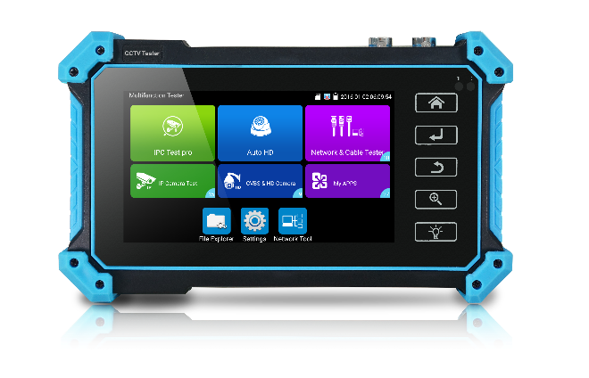
● 8MP CVI/ TVI/ AHD camera test
● 8MP EX-SDI, HD-SDI, 3G-SDI test*
● H.265/H.264, 4K video display via mainstream
● VGA input, support 1920 x 1200P 60FPS*
● HDMI Input, support 4K 30FPS*
● DC12V 3A, 48V PoE power output
● Rapid ONVIF, Create the test report and modify IP address, etc
● Auto HD, auto recognize HD coax camera type and resolution
● RJ45 TDR cable test, cable quality test
● UTP cable test, detect the near-end, mid-end and far-end fault point
of the network cable crystal head
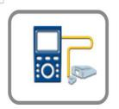
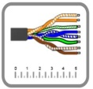
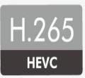
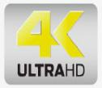

Application

The 5 inch IPS touch screen IP camera tester is designed for maintenance and installation of IP analog, HD coaxial cameras as well as other security equipment. The 1920*1080 resolution enables it to display network HD cameras and analog cameras in high resolution. The unit supports many ONVIF PTZ and analog PTZ control, and cable test functions. CCTV installers often need to carry a variety of testing tools to complete their work. If take the all in one camera tester, making working conditions safer and increasing productivity.
CCTV system installation and maintenance
Network cabling project installation and maintenance
Dome camera, IP TVI CVI AHD SDI 4K H.265 camera testing
Video transmission channel testing
PTZ controller
Features

Camera test:
● 5 inch IPS touch screen, 1920*1080 resolutions
● H.265 & H .264 IP, 4K video display via mainstream
● 8MP TVI test, 3840 x 2160P 12.5/15 FPS, 4xzoom, video record & playback, coaxial PTZ control & call OSD menu
● 8MP AHD test, 3840x2160P 15 FPS, 4xzoom, video record & playback, coaxial PTZ & call OSD menu
● 8MP CVI test, 3840 x 2160P 12.5/15FPS, 4xzoom, video record& playback, coaxial PTZ & call OSD menu
● 8MP EX-SDI test, 3840 x 2160P 25/30FPS,4xzoom, video record& playback, coaxial PTZ & call OSD menu*
● HD-SDI test, 1920 x 1080P 25/30/50/60 FPS, 4xzoom, video record& playback, coaxial PTZ & call OSD menu*
● 3G-SDI test, 1920 x 1080P 50/60 FPS, 4xzoom, video record& playback, coaxial PTZ & call OSD menu*
● Auto HD app, auto recognize HD coax camera type and resolution, support snapshot, video record& playback, coaxial PTZ & call OSD menu.
● VGA input, up to 1920 x 1200P 60FPS, support snapshot, video record& playback.*
● HDMI Input, up to 4K 30FPS, support snapshot, video record& playback.*
● Rapid ONVIF, Auto log in and display image, create testing report
● IPC test pro, auto scan all network segments IP, auto open PoE power and display the power. Input username and password, can scan camera image, can batch activate HIKVISION and Dahua cameras. Jump to ONVIF interface and test tools.
● AXIS, Hikvision camera test, enter ONVIF app, input username and password to test
● HIKVISION test tool, support batch activate HIKVISION cameras and modify IP address, modify password etc. Self-defined modify channel name, can quickly change H.264 and H.265 video, open wide dynamic mode. Factory restore, etc.
● Dahua test tool, support batch activate DAHUA cameras and modify IP address, user name and password. Self-defined modify channel name.
● IP and analog display image at the same time
● IPC TEST (Non-ONVIF test), HIK test tool (Hikvision camera), DH test tool (Dahua camera)
● CVBS camera test, PTZ controller
● DC12V/3A power output, camera can be powered from DC 12 Voltage.
● Rapid video, just by one key to detect all network cameras and auto display
● Built in Wi-Fi, display image from the wireless camera, create WIFI hotspot
Cable test:
● Improvement cable tester, UTP cable, telephone cable etc order and connectivity test, can save testing report, if special number, need customized. Can detect the near-end, mid-end and far-end fault point of the network cable crystal head.
● RJ45 TDR cable test, test cable pair status, length, attenuation, reflectivity, impedance, skew etc, can create test report.
● Digital Cable tracer, search BNC cable, network cable and telephone cable from the mess cables. Cable search and UTP cable can test at the same time *
Other Functions:
● Network tool: Ping, IP scan, Port Flash, DHCP server, Trace Route
● Tester Play: Tester, android version mobile phone and PC display at the same time
● Traffic monitoring, display network port or WIFI connection real-time upload and download speeds and other network parameters
● Customers self update software, you can install apps with android version
● Media player, 4K video files and MKV/MP4 media files play
● Display its genuine resolution of the IP camera images
● Audio in, support record and save the audio/LED lamp, calculators, music players and other application tools
● 7.4 V /3350mAh Li-ion Battery, after 3-4 hours charging, working time lasts 5 hours

Specification

LCD | Item series | IPC-5000 Plus series
 | Display | New 5 inch IPS touch screen, 1920x1080 resolution
Video Mode | CVBS | 1 channel BNC input, NTSC/PAL (Auto adapt)
 |  | PTZ control, RS485 control, Baud 600-115200bps, compatible with more than 30 protocols such as PELCO-D/P, Samsung, Panasonic etc
 | IP camera test  4k/H.265/H.264 | IP Discovery/Quick ONVIF/IPC test /RTSP play /Client APK
 |  | Rapid Video | Auto view the video, create testing report
 |  | HIKVISION test tool | support batch activate HIKVISION cameras and modify IP address, modify password etc. Self-defined modify channel name, can quickly change H.264 and H.265 video, open wide dynamic mode. Factory restore, etc.
 |  | DAHUA test tool | support batch activate DAHUA cameras and modify IP address,username and password. Self-defined modify channel name.
 | HD Coaxial test * | 8MP TVI camera test, 3840 x 2160P 12.5/15 FPS, UTC control/ call OSD menu
 |  | 8MP CVI camera test, 3840 x 2160P 12.5/15 FPS, UTC control / call OSD menu
 |  | 8MP AHD test, 3840 x 2160P 15FPS, UTC control / call OSD menu
 |  | 8MP EX-SDI, HD-SDI, 3G-SDI, UTC control / call OSD menu *
 |  | Auto HD app, auto recognize HD coax camera type and resolution, support snapshot, video record& playback, coaxial PTZ & call OSD menu
 | HDMI input* | 1 channel HDMI input, support 4K 30FPS. The resolution as follow: 4K_3840 x 2160/2K_2560 x 1440P/  1920×1080P /1920×1080i /720×480P /720×576P /1280×720P/1024×768P/1280×1024P /1280×900P /1440×900P, etc
 | VGA input* | 1 channel VGA input, support 1920 x 1200P 60FPS. The resolution as follow: 1920 x 1200P 60FPS/  1920×1080P 60FPS /1792×1344P 60FPS /1680x 1050P 60FPS/(1600x1200P/900P 60FPS)/1440x900P 60FPS/1360x768P 60FPS/(1280x1024/960/800/768/720P 60FPS)/1152x870P 60FPS/1024x768P 60FPS/800x600P 60FPS/600x480P 60FPS.
 | Zoom Image | 4x zoom, to enlarge image, Screen snapshot, record, save, view and record and play back
Power output | 12V/3A power | Output DC12V/3A power out, supply temporarily power for the camera
 | PoE power output | 48V PoE power output, max power 25.5W
Cable test | Digital Cable tracer * | Search BNC cable, network cable and telephone cable from the mess cables. Cable search and UTP cable can test at the same time *
 | UTP cable test | Test UTP cable connection status and display on the screen. Can detect the near-end, mid-end and far-end fault point of the network cable crystal head.
 | RJ45 TDR cable test | Test cable pair status, length, attenuation, reflectivity, impedance, skew, can create test report. measurement range 180M.
Tester Play | screen projection：Tester, mobile phone and PC display at the same time (For android version mobile phone)
Network test | Trace route, Link monitor, DHCP server, port flashing, Ping test
Wi-Fi | Built in WIFI, speeds 150M, display wireless camera image
Audio test | 1 channel audio signal input, test whether sound normal.
Power management | Display DC 12V input & output voltage and power in real time
Data monitor | Captures and analyzes the command data from controlling device, also can send hexadecimal
External power supply | DC 12V 1A
Battery | Built-in 7.4V Li-ion battery, 3350mAh
Rechargeable | After charging 3-4 hours, normal working time 5 hours
Operation setting | OSD menu, select your desired language: English, Chinese, Korean, Russian, Italian, French, Polish, Spanish, Japanese, Deutsch, Turkish Portuguese, Czech etc
Auto off | 1-30 (mins)
Working Temperature | -10℃---+50℃
Working Humidity | 30%-90%
Dimension/Weight | 183mm x 110mm x 36.5mm /0.32kg

Note: “*” sign mean functions are customizable
The data above is only for reference and any change of them will not be informed in advance. For more detailed technical inquiries, please feel free to contact us

Comparison Table:

Features/ Model | IPC-5000Plus | IPC-5100Plus | IPC-5200Plus
AHD | √ | √ | √
TVI | √ | √ | √
CVI | √ | √ | √
HD-SDI/3G-SDI/EX-SDI* | X | X | √
HDMI IN* | X | √ | √
VGA IN* | X | √ | √
Battery | 2600mAh | 3350mAh | 3350mAh
Digital Cable tracer* | Optional | Optional | Optional

Packing kits

- Tester
2) Network cable tester
3) Adaptor DC12V 1A
4) Li-ion battery (7.4V DC 3350mAh)
5) Tool bag / DC Power cable/BNC cable/ RS485 cable/ Audio cable/ wrist belt/Safety cord
6) Manual

